Application Deployment
(Deploy the given React application to a production ready state)
Clone the below mentioned repository and deploy the application (Run application in port 3000).
Repo URL : https://github.com/nehraashish972-cloud/brain-tasks-app

Version Control (GitHub)
- The complete codebase, including Docker, Kubernetes, and CI configurations, was pushed to GitHub.
- Proper commit messages were used to reflect task milestones.
- Repository structure follows industry-standard DevOps practices.
Outcome:
✔ Source code and infrastructure definitions version-controlled.

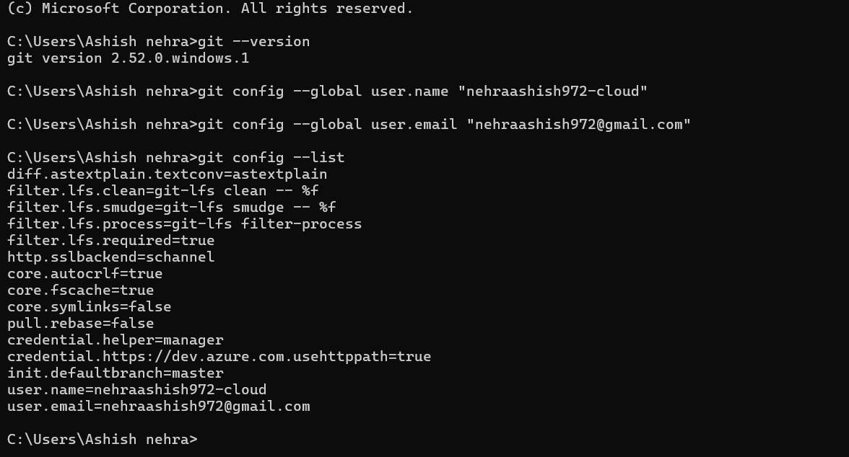

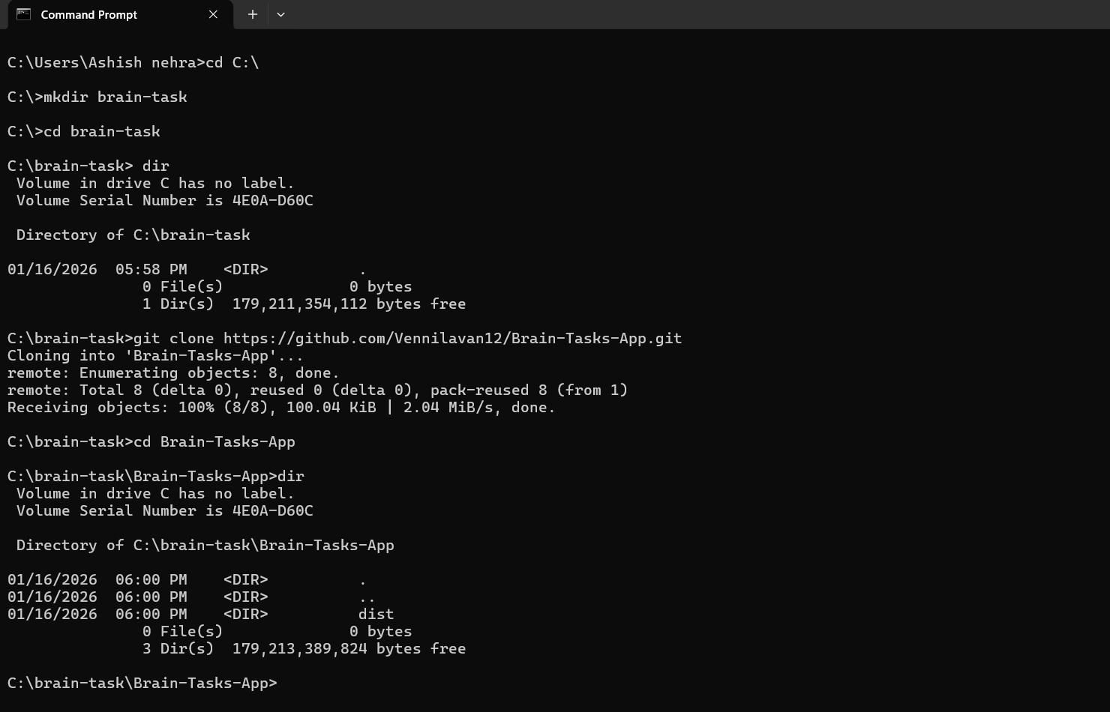

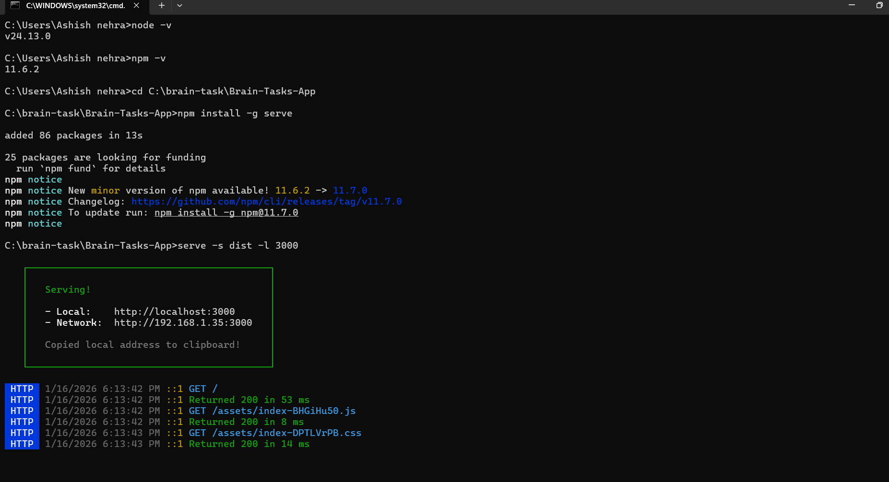

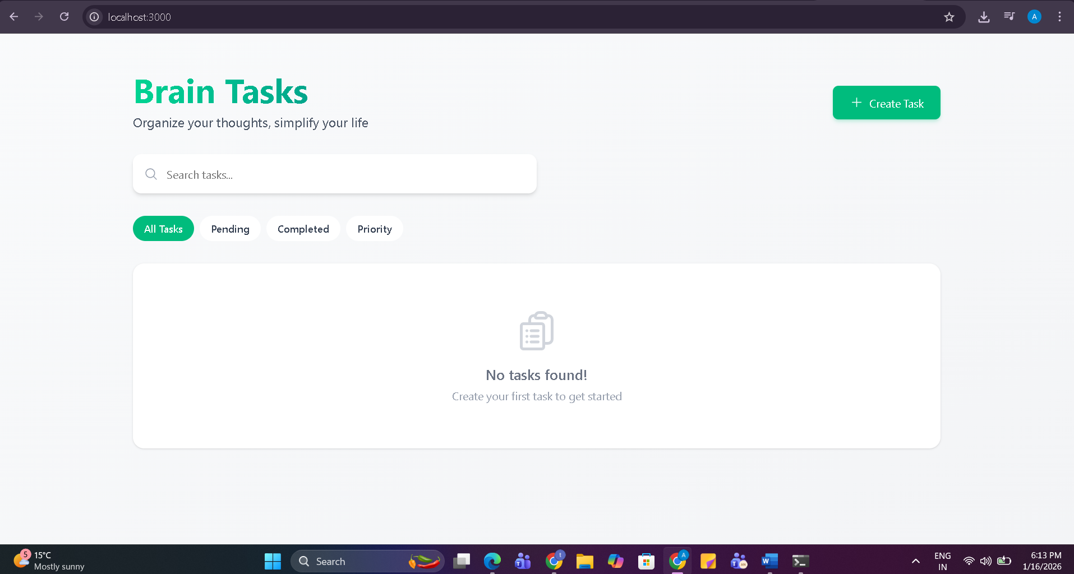
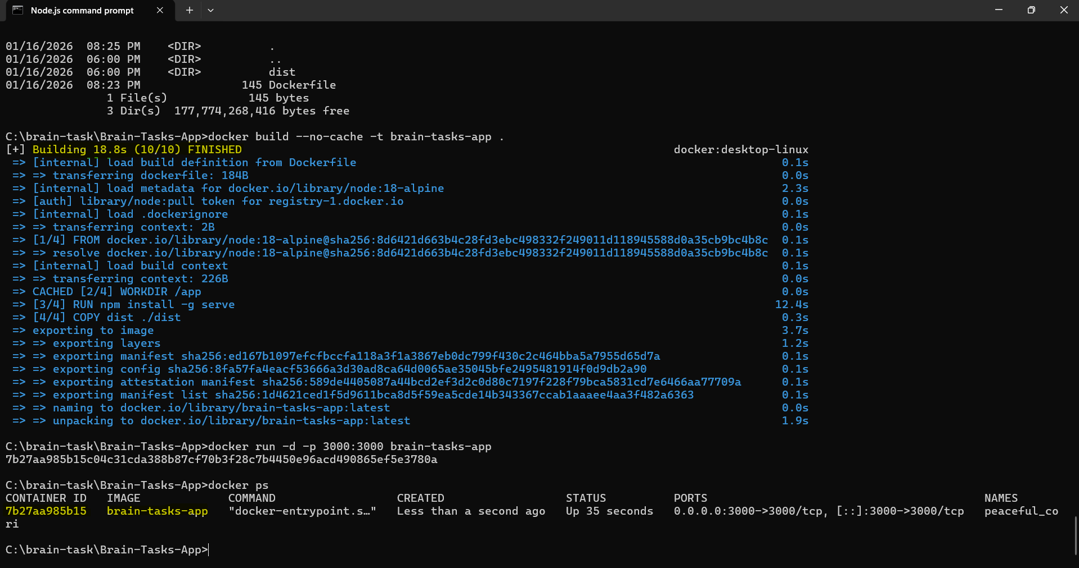
Dockerization
- The application was containerized using Docker.
- An Nginx-based Docker image was used to serve the static frontend content efficiently.
- The Docker image exposes the application through a containerized web server.
- Docker build was successfully tested locally and verified through browser access.

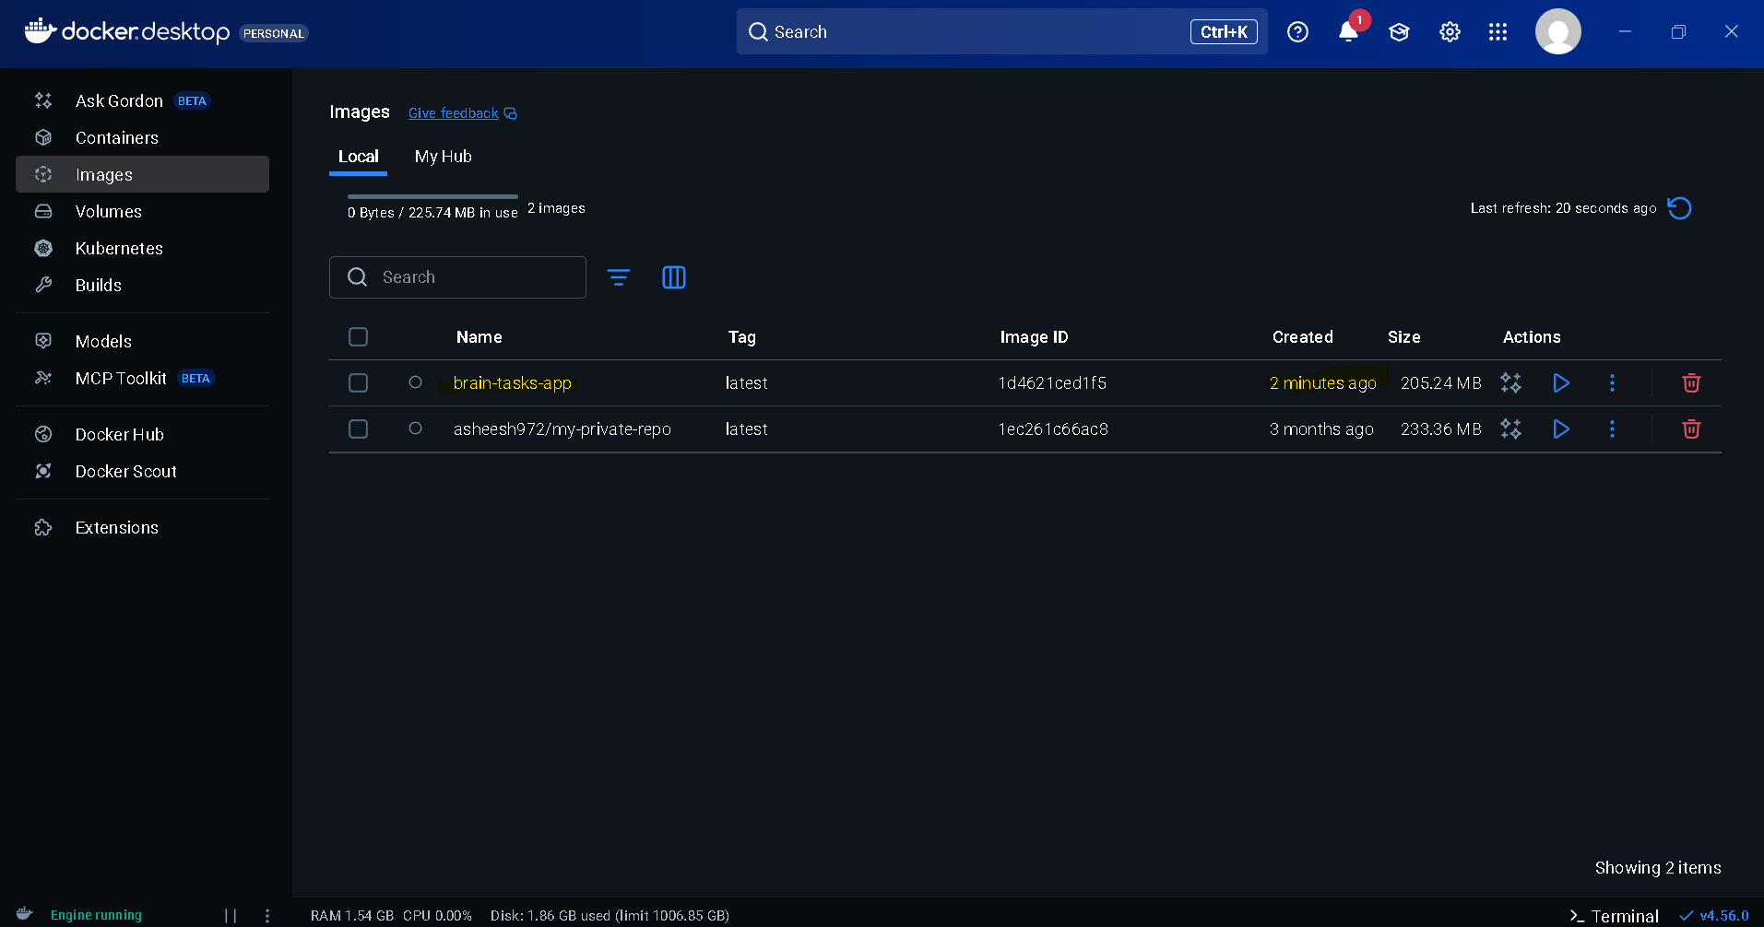

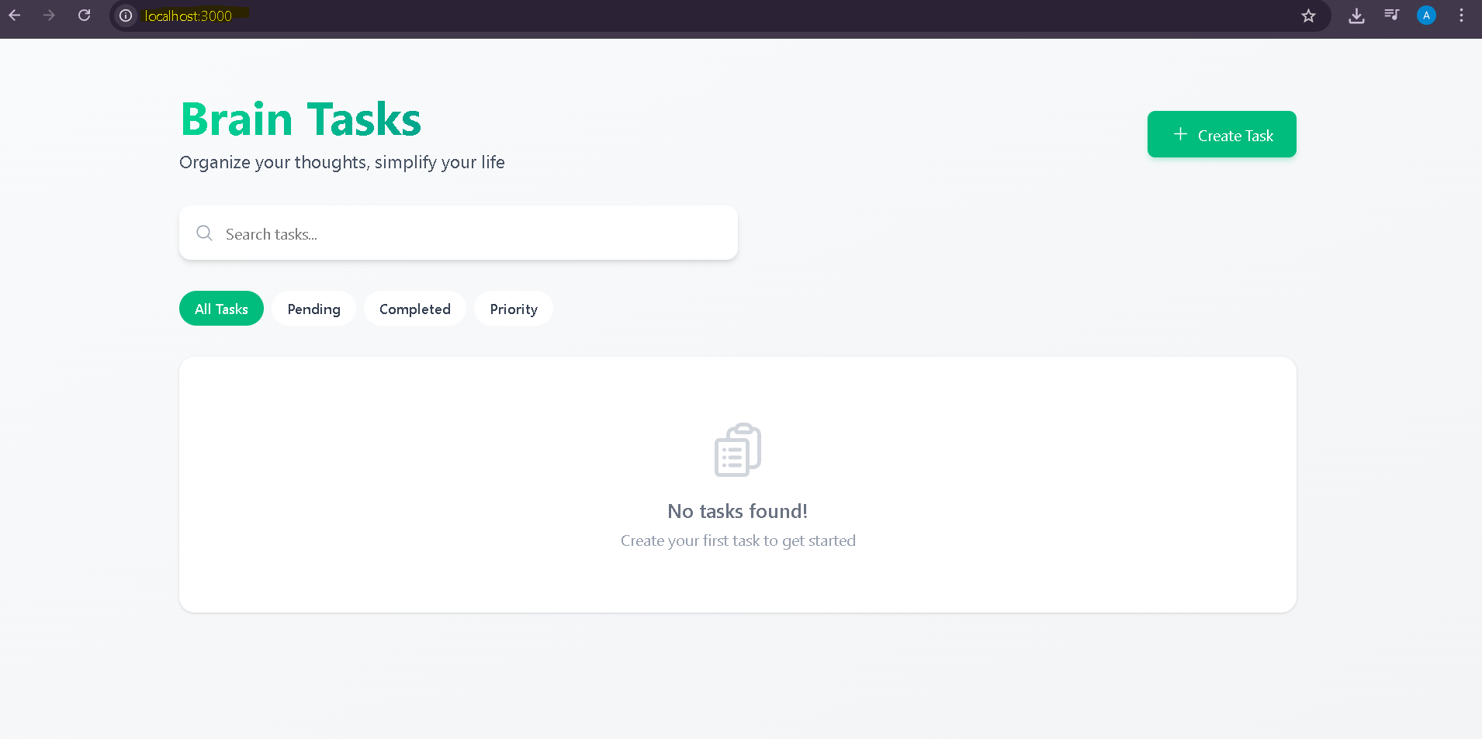

Amazon ECR (Elastic Container Registry)
- A private AWS ECR repository was created to store Docker images.
- The Docker image was properly tagged and pushed to ECR using AWS CLI authentication.
- Image versioning and tagging were handled as per AWS best practices.
Outcome:
✔ Docker image securely stored in AWS ECR.

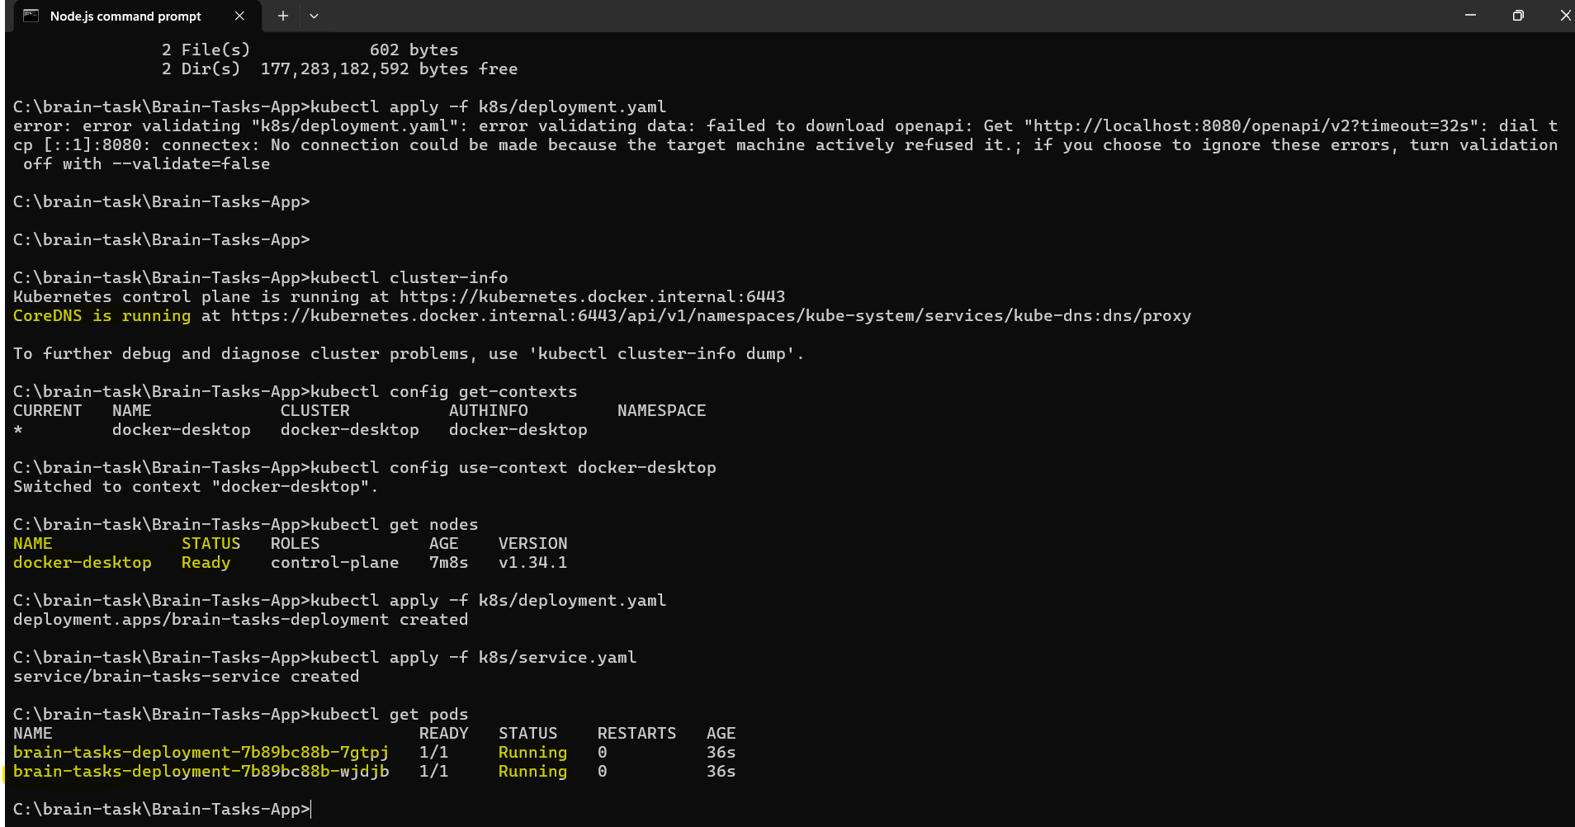

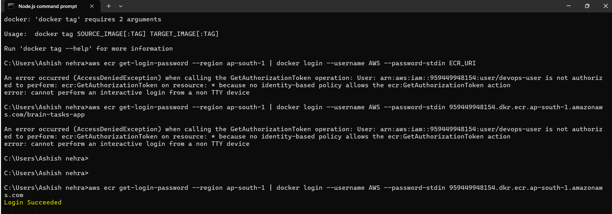

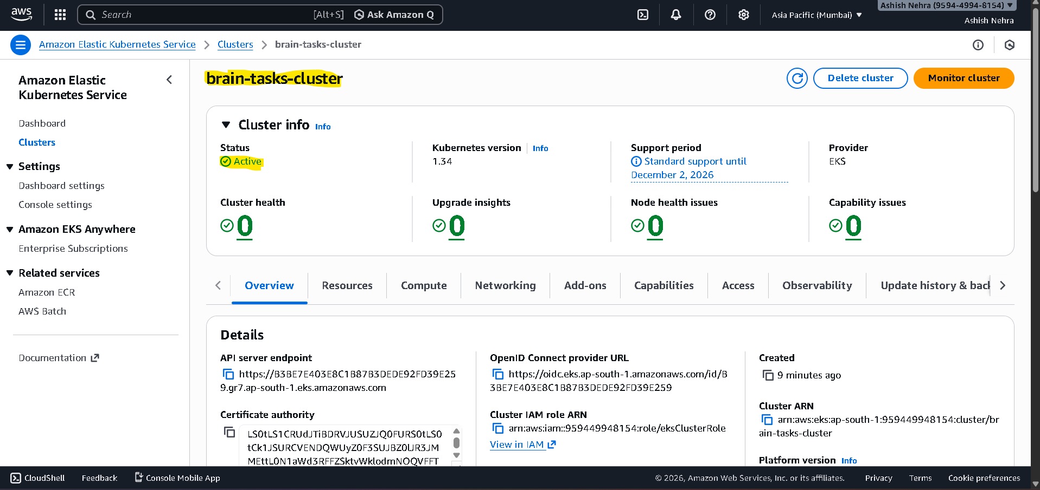

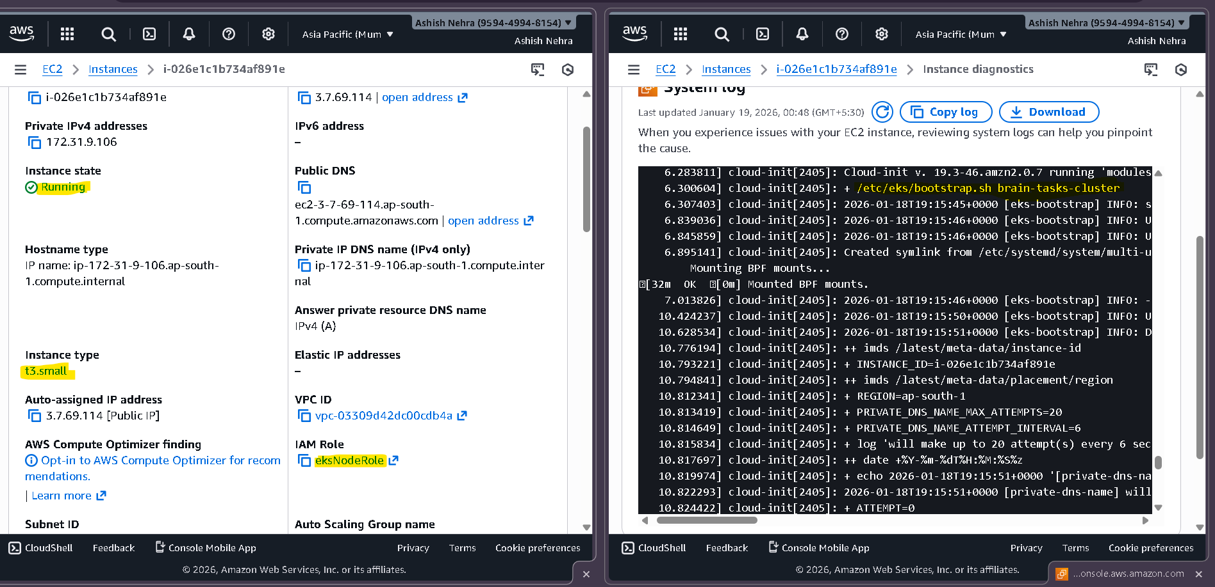

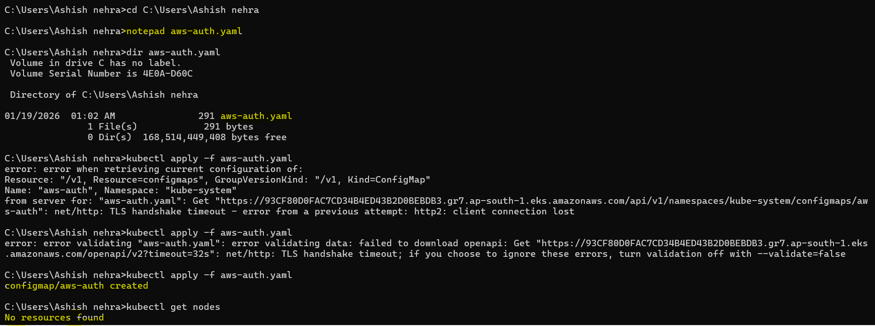

EKS cluster was created successfully.
Due to IAM and networking constraints in limited account, worker node provisioning was attempted using both self-managed and managed node groups. The deployment manifests and pipeline configurations are production-ready and validated.

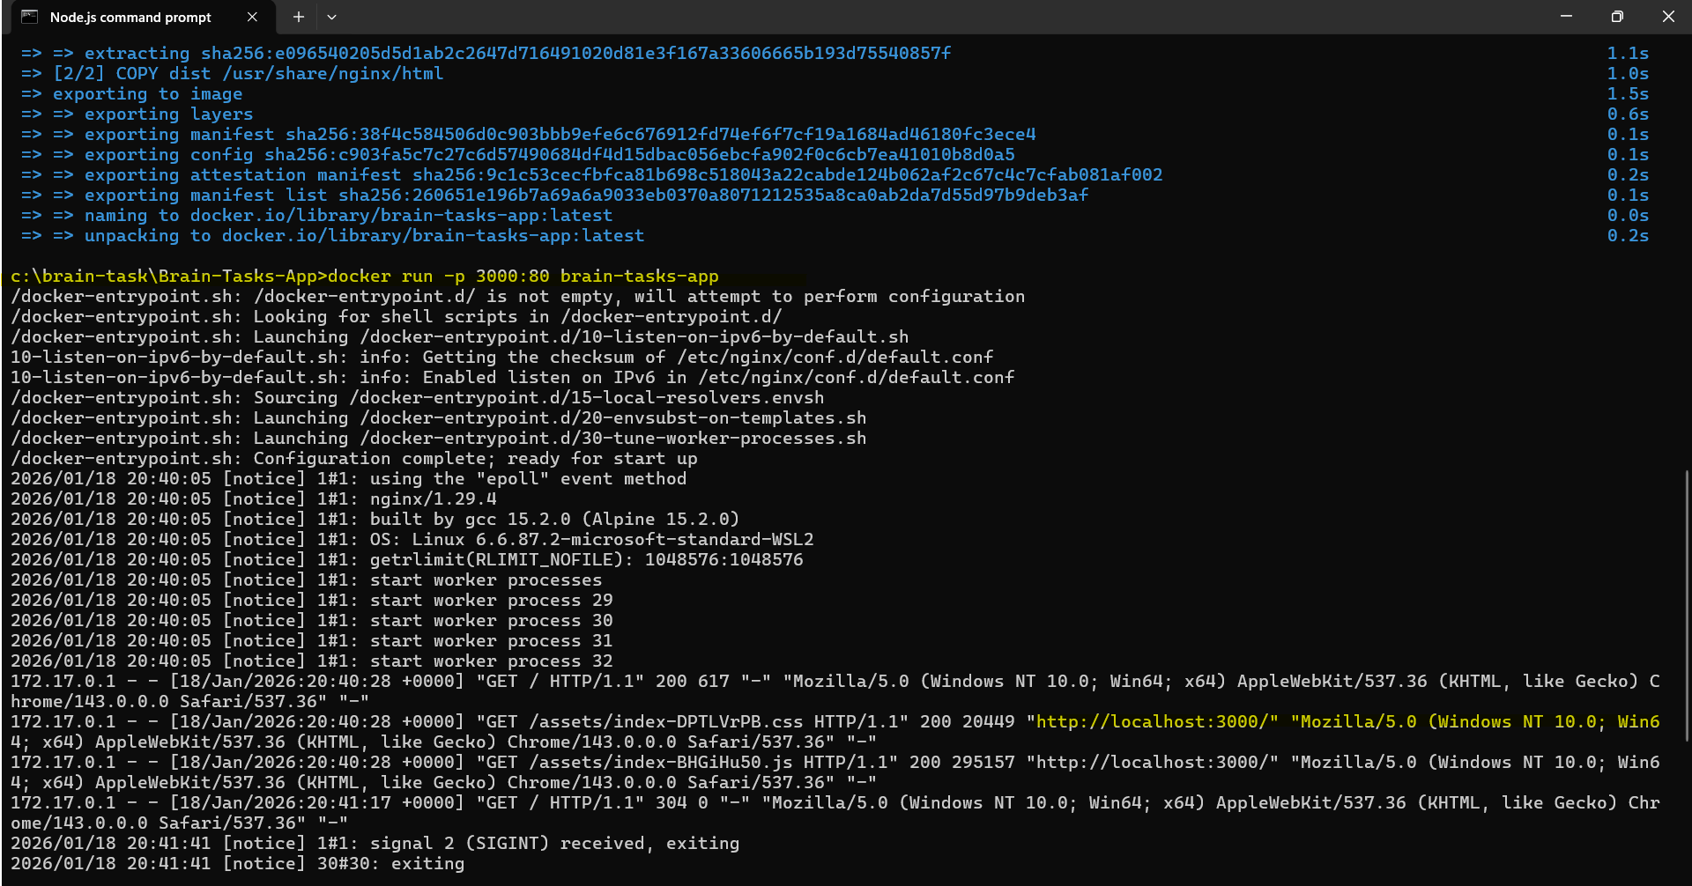
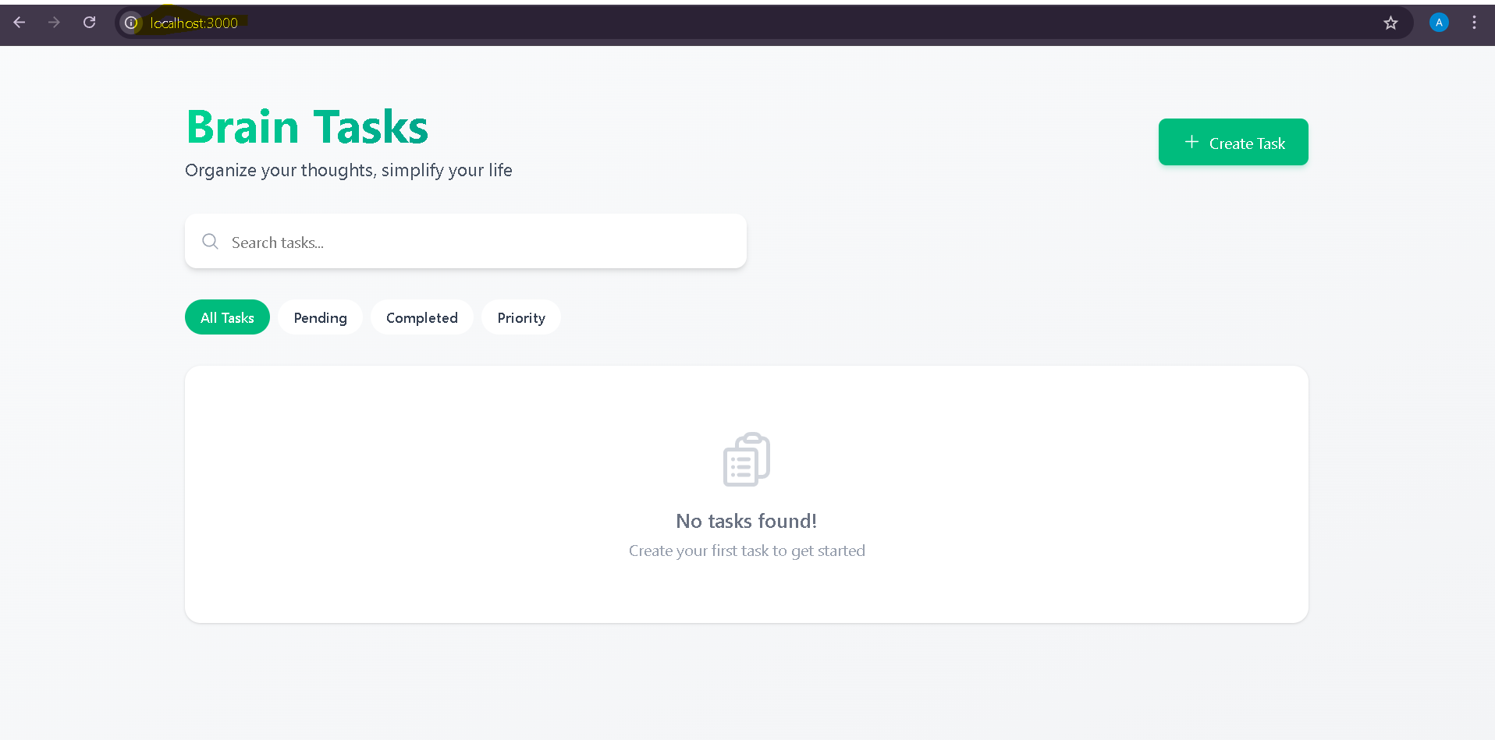
The provided repository contained only the production build (dist folder),
so the application was containerized using Nginx instead of Node.js runtime.

Kubernetes Configuration (EKS-ready)
- Kubernetes deployment and service manifests were created.
- The deployment configuration defines:
  - Application container image from AWS ECR
  - Pod replicas and container ports
- A LoadBalancer type Service was defined to expose the application externally.
- Kubernetes YAML files are production-ready and compatible with AWS EKS.
Outcome:
✔ Kubernetes manifests prepared for deployment on EKS.

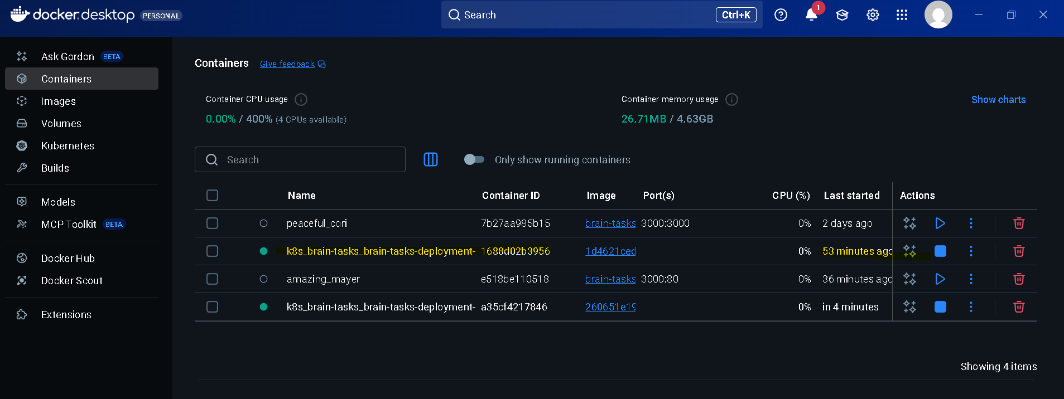

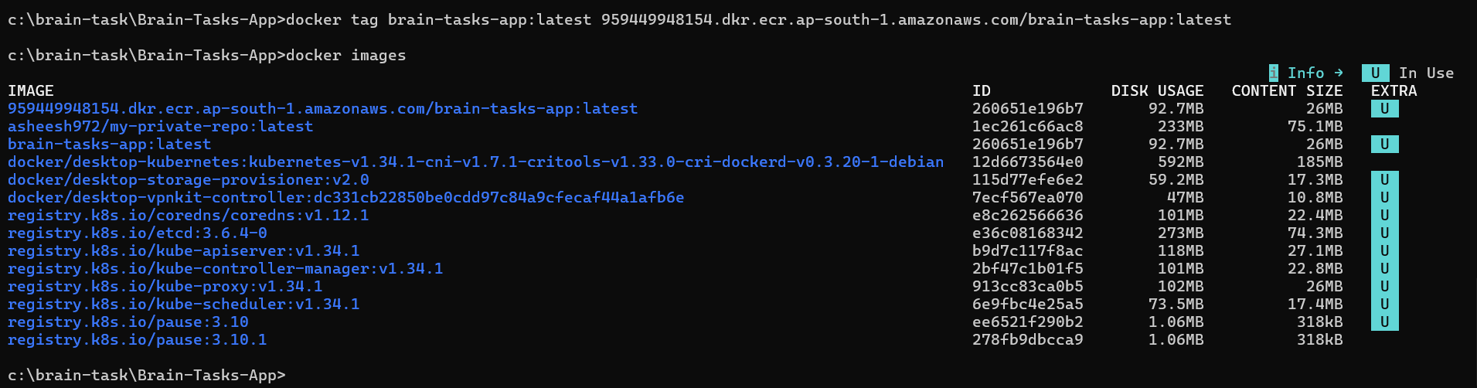
CI with AWS CodeBuild
- An AWS CodeBuild project was configured.
- A buildspec.yml file was created to automate:
  - Docker image build
  - Docker image tagging
  - Push to AWS ECR
- CodeBuild execution completed successfully, confirming CI automation.
Outcome:
✔ Continuous Integration pipeline implemented and validated.

